HTML

📘 Definition
# Source: AI Source: Provided by: [Data Path: Persons Table -> ID Column: 1, Name_En Column: Motasem Essam] -> From: [ChatGPT] on [5/6/2026]
HTML stands for HyperText Markup Language. It is the standard language used to create and structure content on web pages.
HTML is used to:
- Structure content (like text, images, and links)
- Tell the browser how to display content
- Build the foundation of every website
When you open any website, your browser (like Google Chrome or Mozilla Firefox) reads HTML code and shows it as a web page.

🧱 Basic Idea of HTML
# Source: AI Source: Provided by: [Data Path: Persons Table -> ID Column: 1, Name_En Column: Motasem Essam] -> From: [ChatGPT] on [5/6/2026]
HTML uses tags to organize content.
Example:
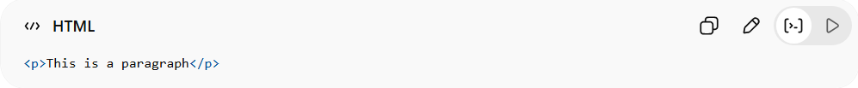
<p>This is a paragraph</p>
- <p> = opening tag
- </p> = closing tag
- The text inside = content

🏗️ Simple HTML Page Example
# Source: AI Source: Provided by: [Data Path: Persons Table -> ID Column: 1, Name_En Column: Motasem Essam] -> From: [ChatGPT] on [5/6/2026]
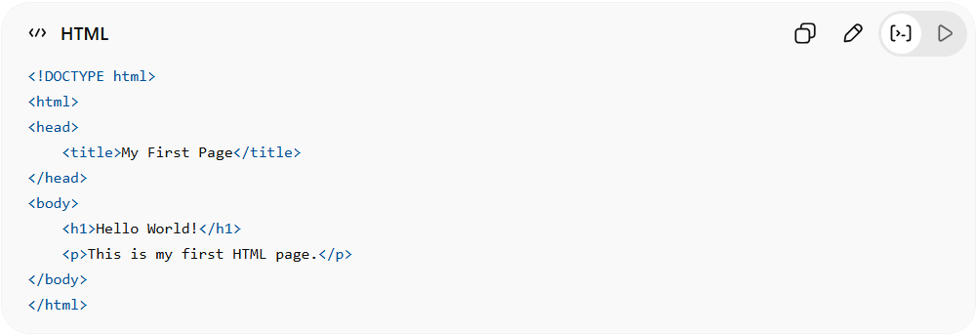
<!DOCTYPE html>
<html>
<head>
<title>My First Page</title>
</head>
<body>
<h1>Hello World!</h1>
<p>This is my first HTML page.</p>
</body>
</html>

🚀 In short:
# Source: AI Source: Provided by: [Data Path: Persons Table -> ID Column: 1, Name_En Column: Motasem Essam] -> From: [ChatGPT] on [5/6/2026]
HTML = the structure of a webpage (the skeleton of a website).

